CDIO APPROACH: DESCRIPTION OF THE EXPERIENCE
IN A BRAZILIAN HEI

José Lourenço Jr, Lucio Garcia Veraldo Jr

Industrial Engineering Department, Salesian University Center of Sao Paulo,
Campus Sao Joaquim, Lorena, Brazil

ABSTRACT

The paper aims to present the experience of a Brazilian Higher Education Institution, private and nonprofit religiously-affiliated university, in implementing a new model curriculum. The strategy was to seek innovative and modern experiences to incorporate into the new programs by means of literature searches, benchmarking and visits to institutes of higher education outside of Brazil, all guided the CDIO™ Initiative. The HEI was started in 2011 six new careers in Engineering, at campus São Joaquim: Industrial, Mechanical, Electrical, Electronics, Civil and Informatics. It proposes to share the experience and the necessary customization to the particular environment. The experience takes place in a higher education with large classes and high heterogeneity in basic education as students with a smattering of Math and Physics, typical problems of developing countries like Brazil. The framework is based on strong interdisciplinary consolidated on a project to each school semester to which are related to the specific contributions for the disciplines of the curricular period. Specifically, this paper present the experience in adopting PBL Project Based Learning in subjects pertaining to structuring the program, specifically in Fluid Mechanics course. The paper discusses the process of structuring the course, idealization and adoption of learning spaces, different of conventional lecture room, like the "Design Thinking Lab", the means of assessment, implementation and results. The re-engineering of programs, even if made easier by starting from scratch, is an ambitious project and UNISAL seeks to be in the forefront of this educational process, working in a structured and evolutionary way, covering programs in many disciplines.

KEYWORDS

CDIO Approach, Salesian, Brazilian HEI, PBL, Standards: 1, 2, 5, 6, 8.

INTRODUCTION

The Salesian University Center of São Paulo (UNISAL) is a private, non-profit religiously- affiliated university that is part of a set of 79 Salesian universities in the Americas, Asia, Africa, Europe and Oceania. It is a medium-sized university by Brazilian standards, with close to 13,000 students at four university campuses. The Salesian passion – the education of young people – has origins in the founder of the congregation, Saint João Bosco and is the inspiration of all of its actions. The integration of knowledge, the dialogue between faith and reason, continuous search for truth, ethical development, the spirit of liberty and charity, mutual respect and the promotion of human rights characterize and animate UNISAL as a knowledge center that gives flavor to studying and research and promotes the acquisition of real-life knowledge.

In 2010, the Lorena campus decided to create courses in the engineering area. The Industrial Engineering program was started in 2011, and immediately following courses of Civil, Electrical, Electronic and Computer Engineering were added in 2012. Finally, in 2013, a program in Mechanical Engineering was added to the university’s portfolio.

The Brazilian educational environment at the time these programs were introduced, not unlike the present day, was characterized by challenges, opportunities and constraints. Statistics from CONFEA (the Brazilian Federal Council of Engineering) count the number of engineers currently at 706,000, equivalent to six per thousand economically active people. To these 20,000 new engineering graduates are added every year. A key detail: in Brazil almost half of the engineers opt for Civil Engineering while in developed countries a large percentage choose disciplines closely linked to high-tech. However, challenges in Latin America such as social inequality, economic stagnation and shocks in the interaction between man and ecology should seek to confront these problems through engineering and technology. Finally, this scenario of not having enough engineers nor even engineering students to meet the needs of the country to incorporate technology, adds to the quality problem that has affected much of higher education. The deficiencies in primary and secondary education are carried over into the university level.

It is true that much of the crisis faced by Brazilian Engineering has its origin in elementary and secondary education, where "math aversion syndrome" is a bigger problem that lack of verbal or reading skills. The dropout rate of about 50% of engineering students over the first two years of the program has to do mainly with the poor preparation in math skills and the cumulative deficiencies in language skills (INOVA Engenharia, 2006). As a result, the new courses, from conception, were defined using other paradigms. From the beginning, the programs were designed with the conviction that it would be necessary to introduce practical and contextual content as an essential factor to enable the assimilation of theoretical concepts in a practical manner. Besides this, it would be an important motivating factor for the student, helping to reduce dropout rates. The designed association of theoretical and practical activities enables the future professional to intervene in a practical way, mastering the nuances of reality through simulated activities such as exercises, papers, case studies, and practices not directly associated with the theoretical content of the courses used. The current prevailing model for training engineers provides the student with only a "two-dimensional" representation, when reality is three-dimensional and complex. Without a connection to practical reality, theory loses its role as an important tool for understanding.

UNISAL APPROACH USING CDIO AS A PROGRAM MODEL

In the face of such barriers and difficulties, there was a need to adopt unconventional approaches when creating new programs of study. The effectiveness and sustainability of the new courses would have to be supported by the ability to identify necessary changes and make sure they taken account of; one would not expect different results if the same traditional paradigms were maintained. On the other hand, the opportunity to start from scratch provided an enthusiastic motivation for change.

The strategy was to seek innovative and modern experiences to incorporate into the new programs. Literature searches, benchmarking and visits to institutes of higher education in and outside of Brazil all guided the CDIO™ Initiative. Although the presence of professors and coordinators formally dates from the 9th International Conference, the approach taken to design these courses was considered from the first conceptual outlines of the CDIO proposed methodology.

Table 1. Competency Requirements for the Graduate

Competencies | Graduates should be able to…
Qualitative Analysis | Analyze and solve problems in engineering and other disciplines qualitatively, including estimation, analysis with uncertainty, and qualitative prediction and visual thinking.
Quantitative Analysis | Analyze and to solve problems in engineering and other disciplines quantitatively, including use of appropriate tools, quantitative modeling, numerical problem solving, and experimentation.
Teamwork | Contribute effectively in a variety of roles on teams, including multi-disciplinary teams.
Communication | Convey information and ideas effectively, to a variety of audiences, using written, oral, and visual and graphical communication.
Understanding of Context | Demonstrate understanding of the ethical, professional, business, social, and cultural contexts of engineering and other disciplines, and able to articulate his or her own professional and ethical responsibilities.
Lifelong Learning | Identify and address their own educational needs in a changing world, including awareness of personal attributes, fluency in use of information sources, career planning, and self-directed learning.
Design | Develop creative, effective designs that solve real problems though concept creation, problem formulation, application of other competencies, balancing tradeoffs, and craftsmanship.
Diagnosis | Identify and resolve problems within complex systems through problem identification, formation and testing of a hypothesis, and recommending solutions.
Opportunity Assessment and Development | Identify opportunities, to predict challenges and costs associated with the pursuit of opportunities, and to muster resources in response to opportunities.
Source: Adapted from Miller (2005) and Lourenço et al (2014)

In the first steps of program design, the definition of the desired profile for graduates of the courses was strongly aligned with first and second CDIO standards: "The Context" and "Learning Outcomes". For Maximiano (2004) "Competences are knowledge, skills and attitudes necessary for a person to perform activities". Therefore, competencies are developed through learning and work experience, formal and informal education, and family and social life. Competence is knowing how to act in the face of complex situations and knowing how to mobilize knowledge, skills, attitudes and resources (technological, financial, marketing and human) to add value to different kinds of organizations of and become responsible for this while at the same time that also increasing their social value. The greater the complexity of the situations, more intensely knowledge, attitudes and skills are modified (Santos, 2003). From the competencies originally defined by Olin College (Miller, 2005) additional insights regarding the curriculum came from ABEPRO (the Brazilian Association of Production Engineering), and CREA-SP (the Regional Council of Engineering of São Paulo). Stakeholders were consulted through trade associations and this culminated in the establishment of an External Board made up of executives, officials and industry leaders, which defined the skills, abilities and attitudes that should be attained by graduates of engineering programs in the UNISAL Lorena. These are defined in Table 1.

UNISAL represented the desired profile of the graduating student as illustrated in Figure 1. At the base is a “whole” education; this is the structural feature of the desired profile of the student upon completing a UNISAL program and it is guided by the institutional mission. We understand “whole” to mean consistent theoretical education, the development and skills and competencies, unity of theory and practice, the development of strong and Christian ethics, and social and political commitment. The purpose of this is to educate professionals and qualified experts to join professional sectors and to participate in the development and transformation of Brazilian society as autonomous individuals. In Table 1 we present the competencies which comprise whole education, the purpose of which is creating engineering graduates qualified in the "conceiving, designing, implementation and operation" of complex systems and products, especially in collaborative environments.

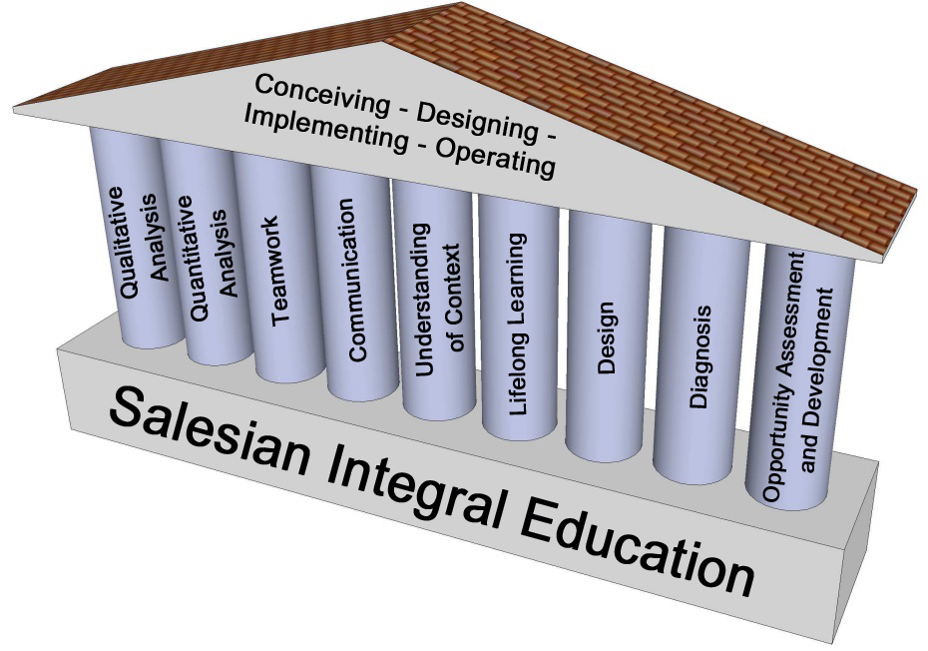

Figure 1. Graduates' Profile of UNISAL Engineering Programs

INTERDISCIPLINARY AND ACTIVE LEARNING

The systematic and planned use of teaching methodologies based on Active Learning was one of the foundations of the pedagogical didactic design adopted for the Engineering courses. This type of learning, as defined by Powell & Weenk (2003), is a methodology that emphasizes teamwork in solving interdisciplinary problems that combine theory and practice. The objective is to create a solution or product from a real situation related to a future professional context. These authors indicated that the main features of this methodology, known as Project Led Education (PLE) emphasize student learning and the students’ active role in this process, in the interests of developing not only technical skills but also soft skills. The methodology is to provide conditions for students to develop these skills, integrating and applying knowledge from different disciplines in a common project which plays a central role in their own learning. This process is focused on the following objectives:

- Promote student-centered learning;
- Foster teamwork;
- Develop initiative and creativity;
- Develop the capacity to communicate;
- Develop critical thinking skills;
- Relate interdisciplinary content in an integrated manner.

The structure of the curriculum was designed for competencies to be developed for each discipline but always in an interdisciplinary and transdisciplinary manner. Every semester (Brazilian programs take 10 semesters) there is a project covering two or more disciplines with clearly-defined contributions to project objectives. Such purposes include the development of both soft and hard skills, and the design of these projects follows an inverse intensity gradient between these skills, as shown in Figure 2. Thus, in the first semesters there is a greater emphasis on soft skills while the second part focuses on hard skills. This practice follows CDIO Standard # 5.

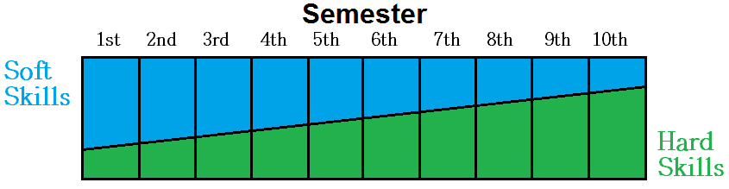

Figure 2. Hard and Soft Skills Gradient

As an example, in the fourth semester of the Industrial Engineering Program students were given a project to design and build a catapult. With stipulated maximum dimensional requirements, students would design and build a catapult to consider at least three launch parameters. They would then, using design of experiment (DOE) techniques, find the best combination of the input variables and then reproduce the optimal release. A competition for greatest horizontal reach was created among the teams. A matrix including each discipline’s contribution toward the project was developed with professors acting as coaches focused on the objectives of the project. Partial and final reports were required and the evaluation criteria considered factors such as fulfillment of proposed objectives, structure, reasoning, conceptual rigor, capacity for reflection and critical analysis, meeting deadlines for delivery and collection of prototype data. Also considered in project evaluation were the project presentations (communication and creativity) and the prototype performance (relevance, correctness and quality of the solution). Figure 3 and Figure 4 show details of the project and launch.

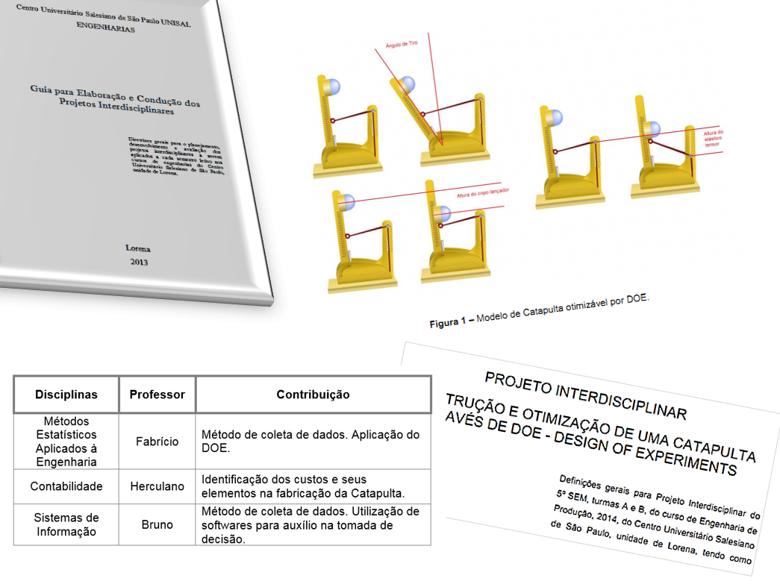

Figure 3. Design a catapult and use of DOE

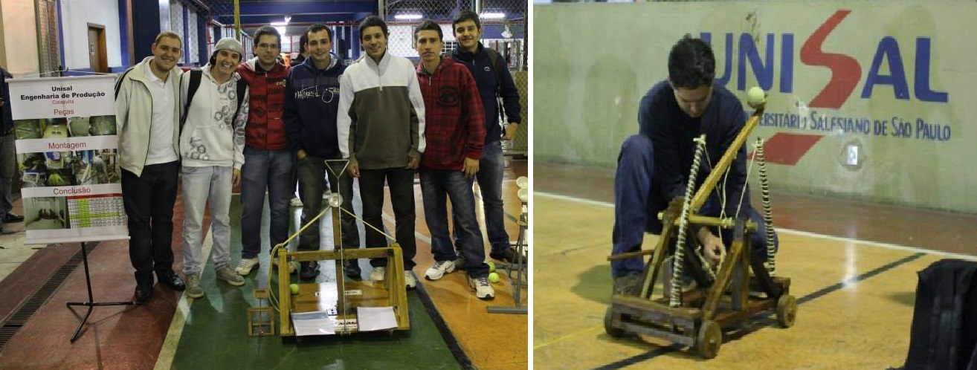

Figure 4. Flagrant launch catapults

ACTIVE LEARNING AND ENGINEERING WORKSPACES

Still following the CDIO approach, an intense commitment to study, knowledge and application of active learning methods was carried out. Since Even before the creation of the Engineering programs, the institution sought the benchmark with other institutions and often conducted faculty exchanges. Along these lines, the unit brought to Brazil several experts and sent professors and administrators to external institutions. One of the first methods used was the Peer Instruction Method developed by Harvard professor Eric Mazur (Mazur, 2013). Professor Mazur visited campus on several occasions and an innovative method laboratory was named after him, as shown in Figure 5 and Figure 6.

At almost the same time, UNISAL Lorena brought Professor Larry Michaelsen of the University of Central Missouri to campus. He was responsible for popularizing the of method Team-based Learning. It employs the use of learning teams to enhance student engagement and the quality of student or trainee learning (Michaelsen, 2002). Figure 7 shows Professor Michaelsen presenting the method to the UNISAL Lorena faculty. Together with TBL, another method that was incorporated is the “Immediate Feedback Assessment Technique”, also known as the IF-AT.
It is a testing system that transforms traditional multiple-choice testing into an interactive learning opportunity and a more informative assessment opportunity for students. The IF-AT uses a multiple-choice answer form with a thin opaque film covering the answer options. Each student scratches off his/her answer as if scratching a lottery ticket. The student scratches off the coating of the rectangle corresponding with his/her first-choice answer. If the answer is correct, a star appears somewhere within the rectangle indicating he/she found the correct answer. The student’s learning is immediately reinforced, the student receives full credit for the answer, and moves on to the next question. If incorrect, the student must re-read the question and remaining answer options and scratch off a second or even third choice until the correct answer is identified. The student will earn partial credit for multiple attempts and learn the correct response for each question while taking the test. One of the keys to the IF-AT system is that students never leave a question without knowing the correct answer (Epstein, 2015).
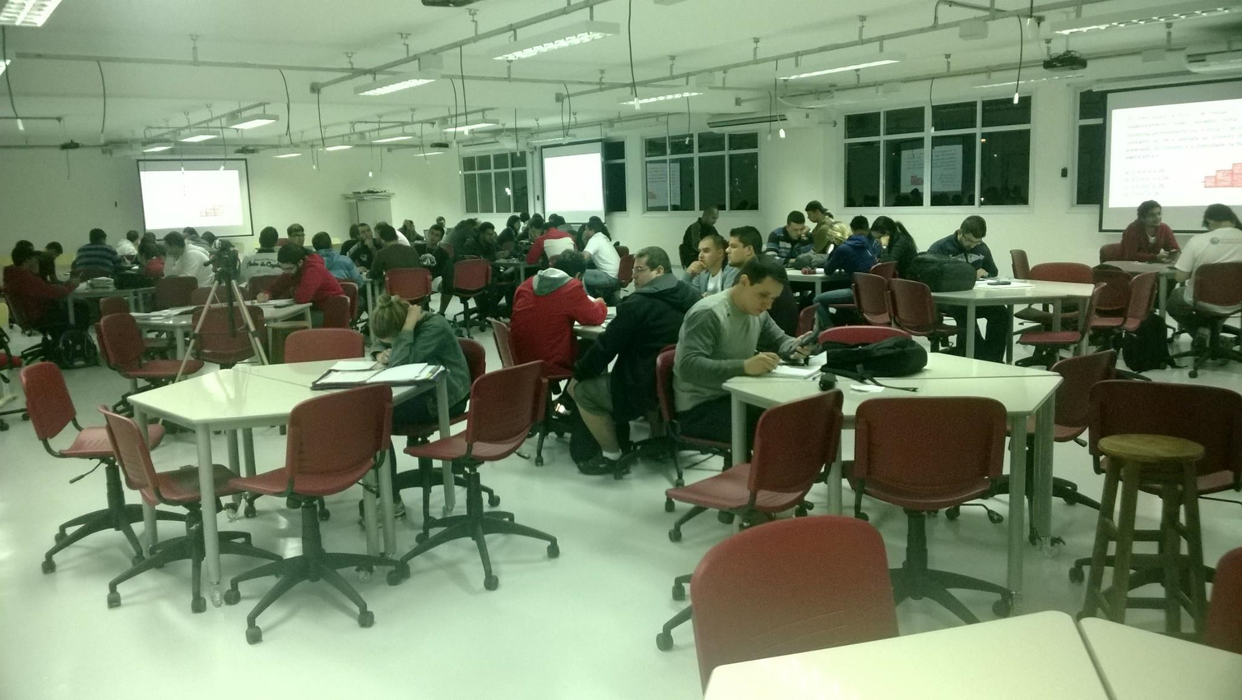

Figure 5. Eric Mazur on his 2nd visit (March/14)

Figure 6. Eric Mazur Lab (indoor)

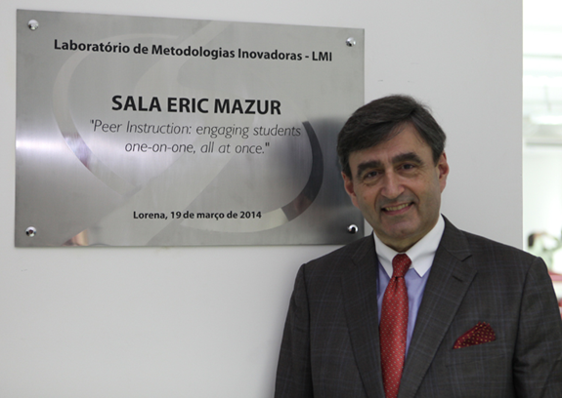
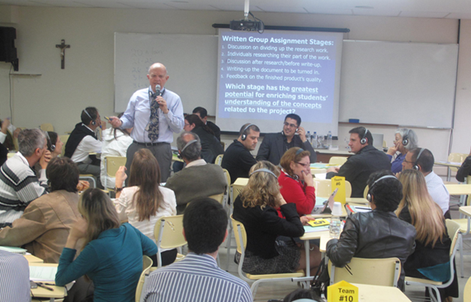

Figure 7. Prof Larry Michaelsen (UNISAL, May 2013)

Also, the Writing Across the Curriculum (WAC) approach became a method implemented in engineering degrees. The WAC approach was used to support the oral communication skills of English Language Learners (ELL) and UNISAL has been adapting it to the Brazilian environment. We have the support of Professor Jennifer Craig of the Department of Comparative Media Studies and Writing at the Massachusetts Institute of Technology. More information about the method can be found in the Proceedings of the 10th International CDIO Conference (Craig, 2014).

When laboratories were built for the programs, large and multidisciplinary spaces were favored. Except for certain specialized environments like, for example basic chemistry and the building processes of Civil Engineering, all of the laboratories were located in the same area without dividers. The size of the lab environments is about 550 square meters and pieces of equipment like oscilloscopes of the electrical and electronics lab coexist with lathes and mills of the manufacturing processes lab. In practice a layout was sought where from basic electricity, to analog and then digital electronics, through the metal forming and material testing laboratories a natural gradient was created between lighter and heavier equipment. Different classes pursuing different types of projects worked simultaneously in the lab. What should have been nuisances such as noise or the greater number of students actually provided an interesting opportunity to blend distinct but complementary content. The students were absolutely at ease and there were identifiable academic performance gains.

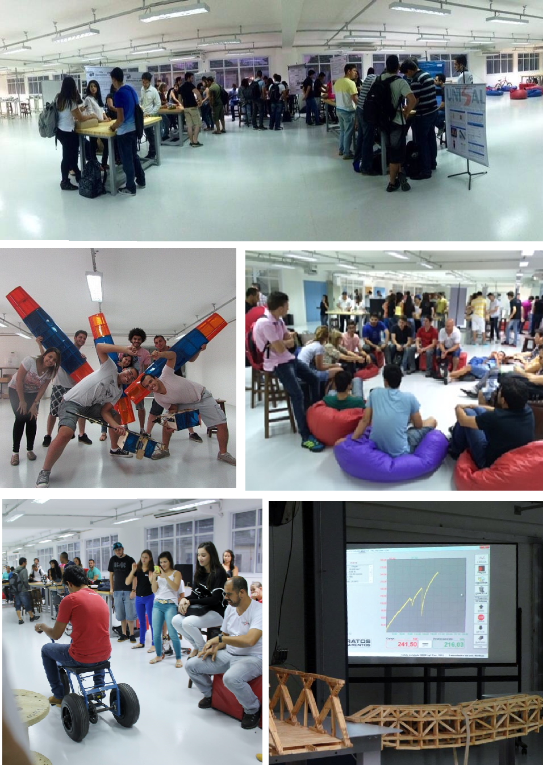

Figure 8. Engineering Workspaces Standard CDIO #6

At the center of the lab, between the electrical and electronics equipment and that of mechanical engineering, there is a space called the "Design Thinking Lab". It has benches, available manual tools, a computer, a 3D printer and a lot of space with stools, sofas and bean bag chairs. There, students are encouraged to innovate with designs and prototypes. The environments are open to students throughout the university's operating period. There is a no need for a formal class to be going on, or the presence of a teacher. To ensure safety, there are lab techs who are able to welcome, guide and mentor these students.

FLUID MECHANICS COURSE: NO LECTURE, NO ASSESSMENT

The first experience in delivering a discipline exclusively via PBL (Project Based Learning) occurred with fourth semester engineering students in the Fluid Mechanics class. It took nearly a year to prepare and format the course; all meetings, activities and projects were prepared and tested in a pilot. The conceptual, procedural and attitudinal objectives of the course were developed from a contribution matrix with each proposed activity. Throughout the semester, the forty class hours were divided into twenty meetings, one per week, and about forty hours outside of class were added.

The dynamic that was developed was essentially as follows: students were "challenged" to perform an activity prior to class: it could be reading something, but most of the time it was a practical task. For example, the challenge could be the calculation of a specific force in a submerged surface or a problem related to software that simulates Reynolds number. The students would work in teams outside of class although feedback would occur individually through the online system. Then, in class, in a period of around 20 minutes, students would individually answer a given set of problems and issues. Afterwards the same problems and issues were presented to the teams and, this time, working towards consensus, they would seek the correct alternative from the starting point of their individual opinions. This is where the learning actually happens, when students explain their opinions to each other.

At the same time as the above activities, all course content was divided into three structural axes that generated three projects that were presented formally in writing evaluated by professors and especially-invited industry professionals. No specific requirement was made about the projects, except for their adherence to the principles of the related axes. This flexibly resulted in a very gratifying outcome: each project is an auspicious surprise. In fact learning of a concept happens as a consequence of the chosen project, and not the other way around. So it's simple: if the student cannot learn the concept, he cannot complete the project.

There were no lectures for this class. Sometimes the professor would address the class to inform them about objectives or provide an overview. This never took more than ten minutes and only occurred from time to time. The entire course was developed to be performed in laboratories in the "Design Thinking" environment described above in this article. The grading is done in a continuing process that promotes learning. The grade for each student is a combination of their individual and group performance on course activities. Throughout the above process, the professor was available to provide guidance and answer questions. Rather than "teaching", the professor is more of a coach.

CONCLUSION

Active teaching methodologies have been employed for decades in various parts of the world, and the results have been published. In Brazil, these methods have not been systematically used and there has little about the Brazilian experience in the literature.

The re-engineering of programs, even if made easier by starting from scratch, is an ambitious project and UNISAL seeks to be in the forefront of this educational process, working in a structured and evolutionary way, covering programs in many disciplines. The application of any active method for the first time requires a coherent planning of activities in order to prepare both the materials and the means that will be used in the teaching process, but, above all, guide the teacher in the dynamics of learning.

The "blank page approach" on one hand is an invitation to innovate but on the other hand requires a carefully designed structure. The CDIO proposal has been essential for the valuable resources it has provided such as the Syllabus and the twelve standards, but also because of the qualified experience of the international academic community.

REFERENCES

Craig J. (2014). Oral Communication in Rapid Prototyping Design at a Russian University. Proceedings of the 10th International CDIO Conference, Universitat Politécnica de Catalunya, Barcelona, Spain

Epstein Education Enterprises. Available in http://www.epsteineducation.com/home/about/, last visit on 01/16/2015.

Inova Engenharia (2006). Propostas para a Modernização da Engenharia no Brasil. Confederação Nacional da Indústria CNI, Serviço Nacional de Aprendizagem Industrial (SENAI) e Instituto Euvaldo Lodi (IEL). Brasília.

Lourenço Jr, J. et al. (2014). Education Curriculum Design of the Industrial Engineering Program. UNISAL Salesian University Center of São Paulo. Campus Lorena.

Maximiano Amaru, C.A. (2004). Introdução à administração. 6. Ed. Revisada e Ampliada. São Paulo. Editora Atlas

Mazur, Eric. (1996). Peer Instruction: A User's Manual. Pearson Education (US), United States.

Michaelsen, L. K.; Knight, A. B.; Fink, L. D. (2002). Team-based Learning: A Transformative Use of Small Groups. Praeger Publishers, US.

Miller, R. K. (2005). Defining and Assessing the Competencies of Olin Graduates. available in http://www.olin.edu/sites/default/files/competencies_white_paper.pdf, last visit on 12/03/2014.

Powell, P. C.; Weenk, W. (2004). Project-Led Engineering Education, Lemma Publishers, US.

Santos, F. C. A. (2003) Potencialidades de mudanças na graduação em Engenharia de Produção geradas pelas diretrizes curriculares. São Paulo. Revista Produção. v. 13, nº 1.

BIOGRAPHICAL INFORMATION

José Lourenço Jr, Ph. D. (Eng.) is a Professor and Coordinator of Industrial Engineering of Salesian University Center of Sao Paulo, Lorena, Brazil. He is a Consultant, Senior Industrial Executive and Entrepreneur. His current research focuses on Active Learning Methods for Engineering and Lean Production applied to continuous manufacturing.

Lucio Garcia Veraldo Jr, M.Sc. (Eng.) is a Professor of Industrial Engineering and Business Programs of Salesian University Center of Sao Paulo, Lorena, Brazil. He is a Consultant in Production Planning and Project Management. His current research focuses on the influence of active learning methods in Competences Requirements for the Graduate in Industrial Engineering.

Corresponding author

José Lourenço Junior  UNISAL Centro Universitário Salesiano  de São Paulo  Rua Dom Bosco, 284 – Centro  12.600-100 Lorena SP  Brazil  55 12 3159-2033  jose.lourenco@lo.unisal.br | This work is licensed under a Creative Commons Attribution-NonCommercial-NoDerivs 3.0 Unported License.  .

