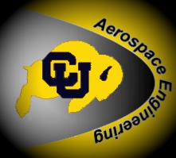


REGISTRATION

AEROSPACE ENGINEERING INDUSTRY SYMPOSIUM
April 19, 2013, 8:00 am – 4:00 pm
University of Colorado at Boulder
Department of Aerospace Engineering Sciences
Boulder, CO 80309-0429

First name: | Last name:
Affiliation:

Address 1: | Address 2:
City / town: | Country: USA
State / province: | Zip / postal code:
Email: | Telephone:

Please register by April 15 if possible. A buffet lunch will be offered to all guests.

RSVP or Mail Registration to
Patti Gassaway: patti.gassaway@colorado.edu, (303) 735-4900, Fax: 303-492-7881

The event will be held in the Discovery Learning Center (Bechtel Learning Collaboratory, 1B50; http://www.cs.colorado.edu/department/maps/dlc.html ) on the Boulder campus of the University of Colorado. Parking is available in Lot 436, across Regent Drive. Parking Permits are $7.75 per day and can be purchased from Police & Parking Services, located in the building on the east sidewalk near the garage, SW section of Lot 436, Regent Dr. (See http://www.colorado.edu/campusmap/ )

Registration tables will be set up at 8:00 a.m. inside the Discovery Learning Center to collect last minute registrations.

Directions to campus: http://www.colorado.edu/visit/directions/index.html

Questions? Contact: → patti.gassaway@colorado.edu, claire.yang@colorado.edu

